**Name :** Pooja Harijiwan

**Batch :** SE-2021 **Section :** B

**Department :** Computer Science And Software Engineering

Examples1 :

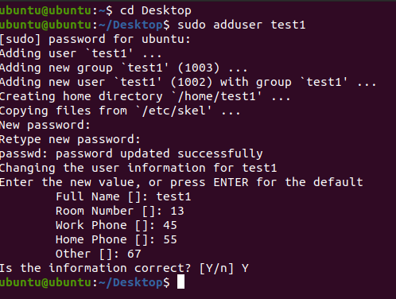

Example 2:



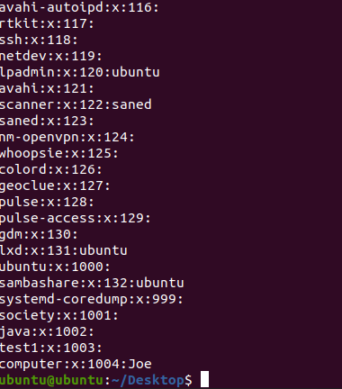

Example 3:

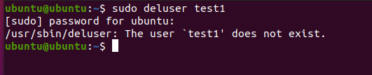

Example 4:

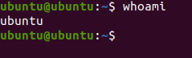

**LAB EXERCISE:**

Q1.Define the following directory structure:

**/bin :**

The /bin directory contains binaries for use by all users. The /bin directory also contains executable files, Linux commands that are used in single user mode.

**/boot:**

The /boot directory contains the files needed to boot the system.

**/dev:**

The /dev directory consists of files that represent devices that are attached to the local system. However, these are not regular files that a user can read and write to : these files are called devices files or special files.

**/etc:**

The /etc directory contains configuration files, which can generally be edited by hand in a text editor. Note that the /etc/ directory contains system-wide configuration files.

**/home:**

A user’s /home directory is intended to contain that user’s files, including text documents, music, pictures or videos, etc. It may also include their configuration files of preferred settings for any software they have used there and might have tailored to their liking: web browsers bookmarks, favorite desktop wallpaper and themes, passwords to any external services accessed via a given software etc. The user can install executable software in this directory, but it will only available to users with permission to this directory. The home directory can be organized further with the use of sub-directories.

**/lib:**

The /lib folder is a library files directory which contains all helpful library files used by the system. In simple terms, these are helpful files which are used by an application or a command or a process for their proper execution the commands in /bin or /sbin dynamic library files are located just in directory.

**/media:**

The /media directory contains sub-directories where removable media devices inserted into the computer are mounted. **For example:** when you insert a CD into your Linux system, a directory will automatically be created inside the /media directory.

**/mnt:**

The */mnt* directory and its subdirectories are intended for use as the temporary *mount points* for *mounting* storage devices, such as CDROMs, floppy disks and USB (universal serial bus) key drives. /mnt is a standard subdirectory of the root directory on Linux and other Unix-Like operating system along with directories such as bin /boot, /dev, /etc,/home/proc, /sbin /usr and /var. As is the case with all other first tier directories in the root directory, /mnt's name always begins with a forward slash.

**/opt:**

/opt is reserved for the installation of add-on application software packages

**/proc:**

The /proc/ directory also called the proc file system, contains a hierarchy of special files which represent the current state of the kernel; allowing applications and users to peer into the kernel’s view on the system.

**/sbin:**

The /sbin directory is similar to the /bin directory. It contains essential binaries that are generally intended to be run by the root user for system administration.

**/srv:**

The /srv/ directory contains site-specific data served by your system running Red Hat Enterprise Linux. This directory gives users the location of data files for a particular service, such as FTP, WWW, or CVS. Data that only pertains to a specific user should go in the /home/ directory.

**/tmp:**

The /tmp directory contains mostly files that are required temporarily. Many programs use this to create lock files and for temporary storage of data.

**/usr:**

Secondary hierarchy for read-only user data; contains the majority of (multi-) user utilities and applications.

**/var:**

/var is a standard sub-directory of the root directory in Linux and other Unix-like Operating system that contains files to which the system writes data during the course of its operation.

Q2. Write a command to:

1. List all files (and subdirectories) in the /proc directory



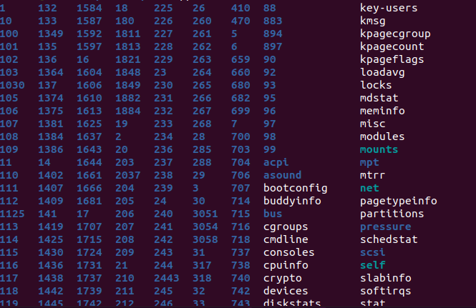

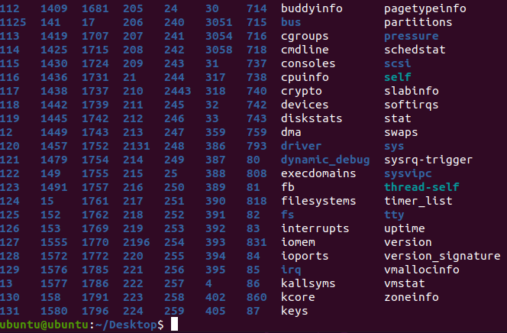

For creating user:

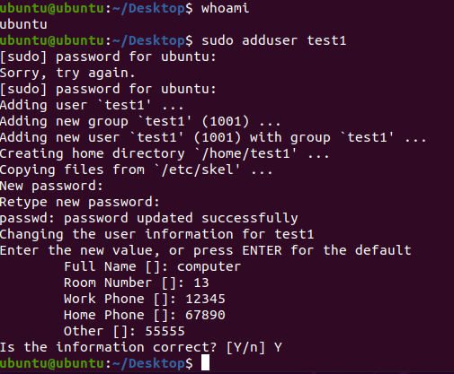

Password will be of ubuntu first

User switch from ubuntu to new created user

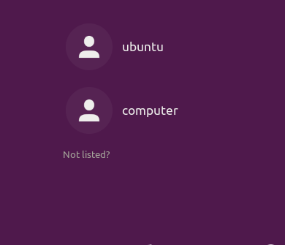

1. Compress the hello.c file

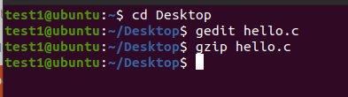

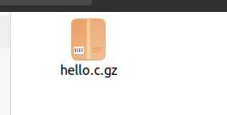

Hello.c file has been zipped.

1. Display the content of /etc/hosts file

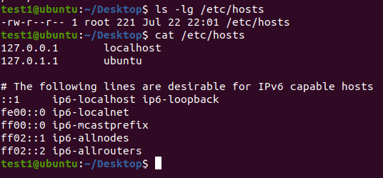

cat is used to display contents of any file,directory or sub directory

1. List the contents of directories /bin and /etc with their permissions

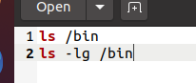



1. Add user Ann and Joe and assign passwords to each of them.

adding Ann

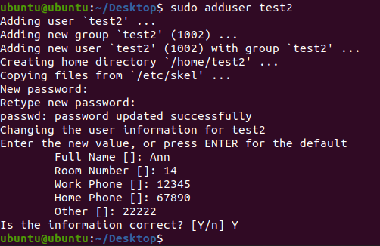

Adding Joe

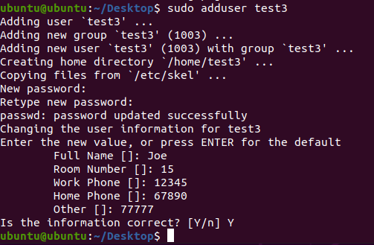

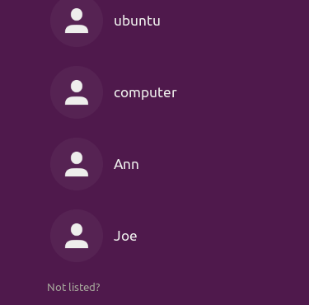

1. Delete user Ann

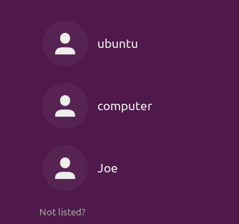

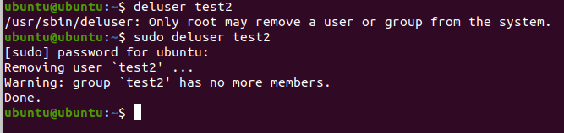

g) adding user in the group

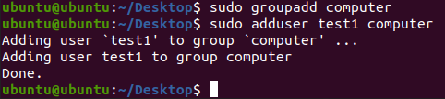

1. 0modify the name of the user





1. Write down the command for listing all the groups.

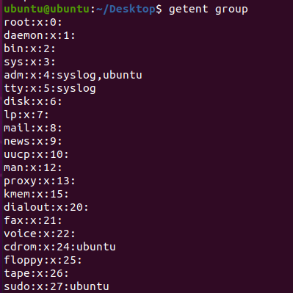

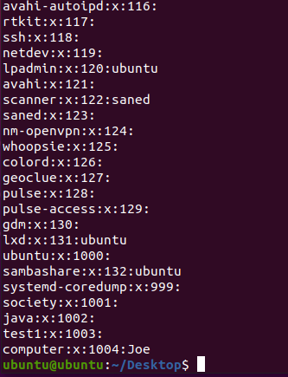

1. Uptime of the system.



1. Present working directory Standard Base Specification (LSB) for run levels?
2. Shut down the system

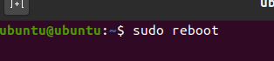

1. Restart the system

